There are ____________ sets of intercostal muscles between each pair of ribs
A. 1
B. 2
C. 3
D. 4
ANSWER: B

Breathing takes place in __________ phases
A. 1
B. 2
C. 3
D. 4
ANSWER: B

____________is the process of taking in of air
A. Inspiration
B. Exhalation
C. Expiration
D. None of these
ANSWER: A

Inspiration is the ____________phase of breathing
A. Active
B. Passive
C. Both Active and Passive
D. None of these
ANSWER: A

During _____________Rib cage moves up and outward
A. Inspiration
B. Exhalation
C. Expiration
D. None of these
ANSWER: A

___________is the removal of air out of the lungs
A. Inspiration
B. Exhalation
C. Inhalation
D. None of these
ANSWER: B

During _____________Rib cage moves down and inward
A. Inspiration
B. Expiration
C. Inhalation
D. None of these
ANSWER: B

Expiration is the ______________phase of breathing
A. Active
B. Passive
C. Both Active and Passive
D. None of these
ANSWER: B

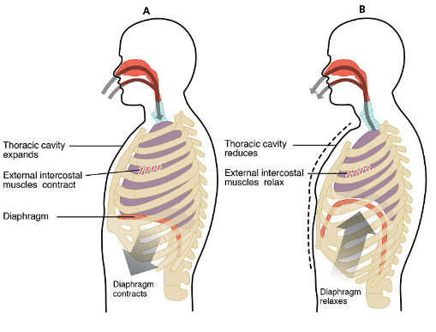
What does A represent in the given diagram?
A. Inspiration
B. Exhalation
C. Expiration
D. None of these
ANSWER: A

What does B represent in the given diagram?
A. Inspiration
B. Expiration
C. Inhalation
D. None of these
ANSWER: B
During inspiration:
A. Diaphragm relaxes
B. Diaphragm contracts
C. External intercostal muscle relax
D. None of these
ANSWER: B

Tidal volume is about ____% of total capacity of lungs
A. 5
B. 10
C. 15
D. 20
ANSWER: B
Oxygen contents per liter of air is
A. 10 ml
B. 100 ml
C. 200 ml
D. 100ml
ANSWER: C
Water is _____ times viscous than air
A. 50
B. 1000
C. 5000
D. 8000
ANSWER: A
The air spaces may comprise upto ______ of total volume of leaf surface.
A. 30%
B. 20%
C. 40%
D. 50%
ANSWER: C
During rest the breathing occurs rhythmically at the frequency of _________ times per minute in human?
A. 16-30
B. 15-20
C. 5-10
D. 6-12
ANSWER: B
The maximum amount of oxygen which normal human blood absorbs and carries at sea level is ________ per 100 ml of blood.
A. 10 ml
B. 20 ml
C. 30 ml
D. 40 ml
ANSWER: B
Haemoglobin can be almost completely oxygenated by an oxygen pressure of __________ of mercury.
A. 10 mm
B. 60 mm
C. 10 cm
D. 100 mm
ANSWER: D
The total average lung capacity of adult human being is about of air:
A. 2 liters
B. 3 liters
C. 4 liters
D. 5 liters
ANSWER: D
Lung volumes are also known as
A. Respiratory volumes
B. Circulatory volume
C. Transport volume
D. Tidal volume
ANSWER: A
It is the amount of air that can be inhaled or exhaled during one respiratory cycle
A. Tidal Volume
B. TV
C. Both A and B
D. None of these
ANSWER: C
It is the amount of air that can be forcibly inhaled after a normal tidal volume
A. Inspiratory Reserve Volume
B. IRV
C. Both A and B
D. None of these
ANSWER: C

